Fall 2014 Senior Design Proposal

Group 2

Prepared for:

Dr. Latcha

Dr. Gu

By:

Paul Kruchko (EE), Project Manager

Michael Laba (ME), Mechanical Design Team Lead

Bryan Jagielo (EE/CE), Electrical and Controls Team Lead

Xiaoang Tong (EE)

Monika Shaeff (CE)

Ran Ao (ME)

Xinfeng Shi (ME)

September 23, 2014

**Introduction**

Senior Design Group 2 was assigned the task of constructing a machine that could efficiently and accurately count parts needed by an assembly worker and dispense those parts into a worker’s awaiting hand, thereby reducing the chance of parts being dropped on the floor and discarded. This proposed device has the potential for optimizing throughput time in the assembly process while saving money in lost and discarded parts.

**Proposed System**

The system that Group 2 proposes is a closed-loop, feed-back, electronically controlled rotating part feeder that agitates, actuates, and organizes a set of homogenous hardware components that are to be counted and dispensed into the awaiting hands of the operator/user.

The overall structure of the system is a rotating plate actuated by a brushed DC motor that is placed in the bottom of a hopper that is angled at a positive 45 degrees from the base of the system and placed at the top-end of the system. The plate inside is fitted with 4 agitators that cause a moment to be produced on the individual parts and allowing them the opportunity to drop into specially shaped reliefs cut into the sides of the plate that allow only one part to occupy a given relief at a time. At the top of the hopper plate is a hole to allow the part riding in the relief to drop into a funnel and descend down a chute. Attached to the chute are 4 pairs of diametrically opposing photo electronic sensors, evenly spaced to count parts to be dispensed and measure the part count, rate of part dispensing and velocity of those parts. Waiting at the end of the chute is a dispense box, that when actuated by the plunger system slides forward to drop the awaiting parts in the hand of the user. At the front end of the system is a flat panel that contains the user interface (UI) and dispense door. The UI consists of; a red lamp and a green lamp, a 2x16 LCD display, a “Select” button, an “Up” button, a “Down button” and a power switch. At the bottom of the front panel is a door that the user must push in with his/her hand to receive the requested number of parts.

The overall theory of operation of the system is that the user would first select the plate that is designated for the desired part to be dispensed then deposit no more than 50 parts at a time in the hopper bowl, which doubles as a hopper. Once the user has deposited the parts to be counted and dispensed into the bowl. Simultaneously the machine would output on the LCD screen, “Please select a part.” The user would then select the profile of the part using the “Up” and “Down” keys and once the desired part was displayed on the LCD screen the user would then press the “Select” button.

Then the LCD displays, “Please select quantity and press ‘Select’”. At this point the user presses the “Up” or “Down” button to select the desired quantity of parts to be dispensed. Once the user has selected the desired quantity of parts to be dispensed he/she would then press the “Select” button initiating the count and dispense sequence. At that time the green lamp would extinguish and the red one illuminate. The LCD would display, “Dispensing parts, please wait…” During the count cycle the motor causes the plate to rotate, agitating parts sitting at the bottom of the hopper bowl. The agitation causes a moment to be produced on the part and fall into one of the reliefs lined on the outside of the plate. The part in the relief then is transported to the top of the hopper bowl towards the dispense funnel. Any part not properly seated in its relief is rejected by the moment caused by gravitational forces acting on the part.

Once the successful count cycle has finished and the desired quantity of parts are dropped into the dispense cup the system would extinguish the red light and illuminate the green light. A message on the LCD would display, “Please push in dispense door to receive parts…” Once the user pushes in the dispense door a transfer rod causes a pivot arm to push the cup forward by another transfer rod and the cup slides forward over the final dispense funnel. The cup itself is bottomless, with only a plate beneath it when the parts are being dropped in from the staging table. This allows the parts to fall through the bottom of the dispense cup, through the dispense chute, and into the awaiting hand of the user. The door/cup system employs the use of a contact switch to determine if the user has fully-actuated the door or not. If the user does not claim the parts the system will wait indefinitely until the user claims the parts. Once the user claims the parts the system again cycles and delivers the same quantity of the same part two more times before going into reset mode and awaiting new instructions.

**Diagrams and Sketches**

**Key Mechanical Components:**

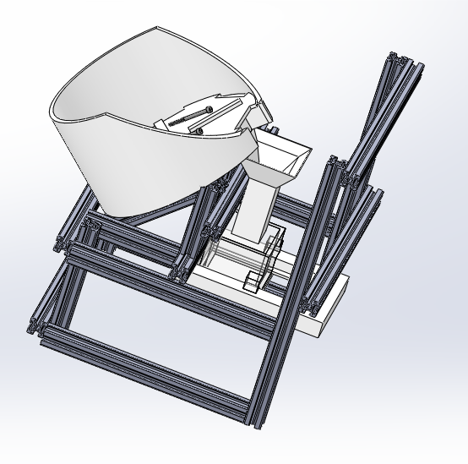

Figure 1. The CAD sketch of Machine Concept

Our machine design is shown above in figure 1. As shown above, a bowl will contain unorganized parts that will be rotated by the different types of wheels. The parts will be fitted into the gaps, and sent to the top of the bowl. Then they will drop into the funnel, where four pairs of IR sensors are waiting for detective the number of the parts. The correct number of parts will drop into the presentation bin. The waiting hand can easily push the slider, and receive the parts when the machine is ready to send the parts.

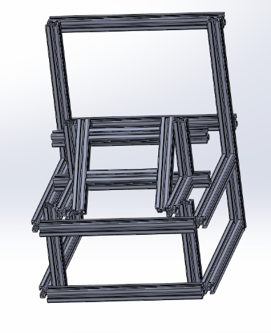 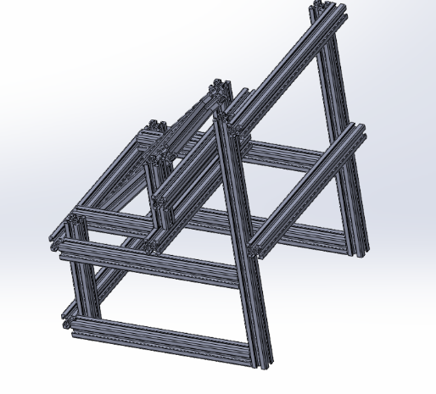

Figure 2. Frame of the total design(direction1) Figure 3. Frame of the total design (direction2)

The frames that we used is shown by figure 2 and figure 3. The are ultilized to hold up all the mechanical components. The cross section of the frame is 20mm×20mm, and the size of the total design is about 350mm×280mm×270mm.

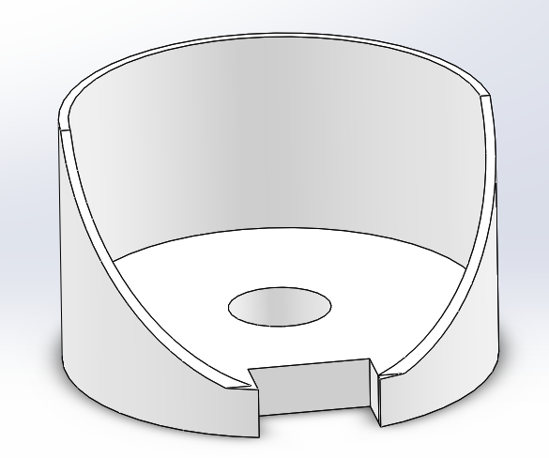

Figure 4. Bowl

The figure above is the bowl, and there is a cuboid gap on the side of the bowl. It allowed the parts dropping into the funnel.

Internal Diameter: 202mm External Diameter: 212mm

The size of the gap: 6021mm

The bowl is holding up with an angel of 45 degree.

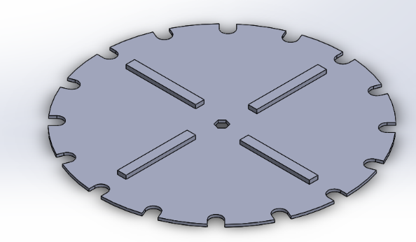 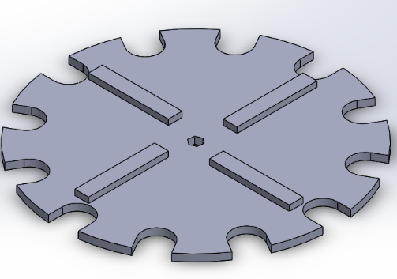 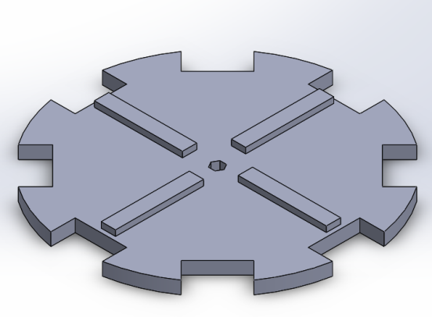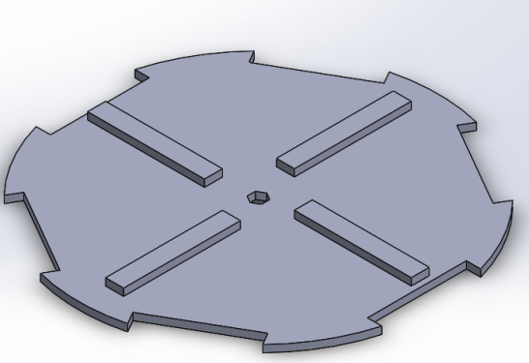

Figure 5. Different types of wheel for rotating different parts

Diameter: 200mm

Thickness of the gap: The half of the thickness of the parts plus 1mm

The size of the agitator: 60104mm

The number of the gaps for each part is shown in the graphs

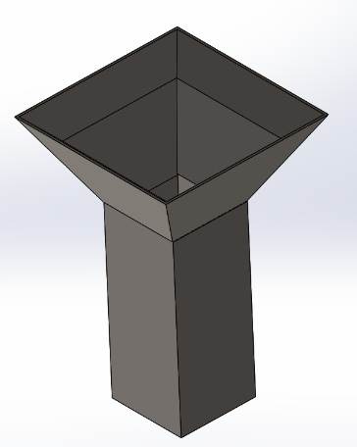

Figure 6. Funnel

The upper size of the funnel is 60mm. The internal size of the cylinder is 22mm. The angle of the slope is 45 degree. The thickness of the funnel is 5mm. Four IR sensors are inserted to the funnel. Four pairs of IR sensors are inserted to the funnel to correctly count the number. In order to avoid getting stuck, the slop is smooth enough, and we might add a bumper to change the direction of the long parts if there is a needed.

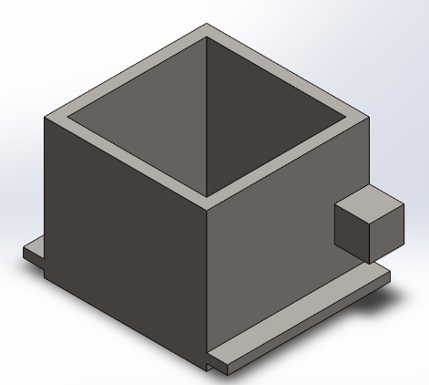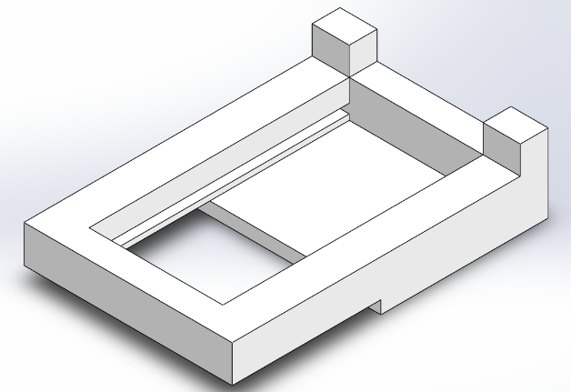

Figure 7. Presentation bin Figure 8. Push slider

Below the funnel, the presentation bin and the push slider are utilized to receive the parts. We can easily push in, and the parts will be directly damped into the hand.

*All 80/20 CADD models found on www.8020.net

**Electrical and Electronic Components:**

Microcontoller selection: Arduino Mega 2560 R3

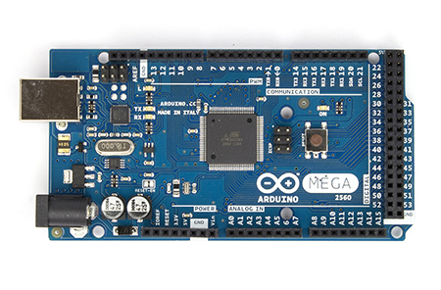

*Arduino Mega 2560 R3 Front\**

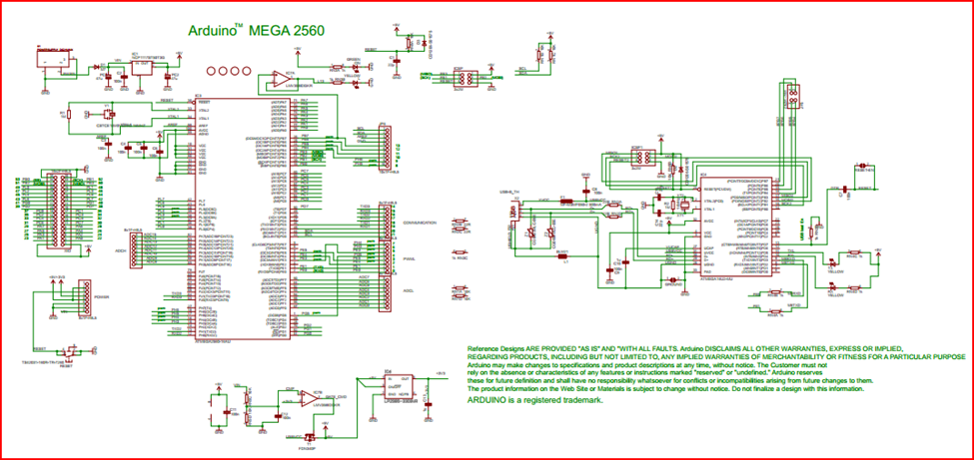

**Arduino Mega 2560 R3 Electrical Schematic\***

*Arduino Mega 2560 R3 schematic and picture gleaned from <http://arduino.cc/en/Main/ArduinoBoardMega2560>

**Using an IR led to make IR emit and receive system**

Components: A 5mm IR led, IR receiver: TSOP34338, Arduino 2560 R3, Cylinder crust, resister and wires

It is not necessary to add a lens in emit system, because IR led has already had similar structure.

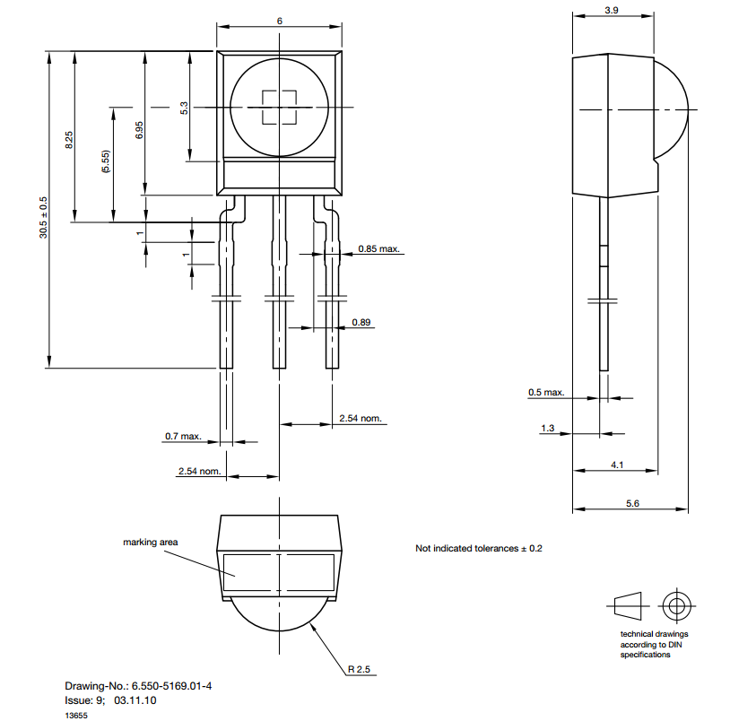

**Emitter:**

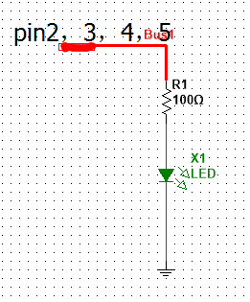

For the emitter side, we have to generate a carrier wave with 38 KHz. We decide to utilize PWM to generate carrier wave from the Arduino Microcontroller which is setting with 16 MHz working clock. Arduino board is supplied by 5v power and the maximum current of each pin is 40mA. The IR Led uses IR333-a, the maximum current in the output port is 20mA.

Depend on f=1/T=>38 KHz==>T=0.026us

What we get is that one period is 26us. Converting into digital signal is 1 for 13us delay and 0 for 13 us delay, and then repeat it forever.

In order to drive 4 sensors, we have to pick up four pairs of I/O ports: pin2 and pin 10, pin3 and pin11, pin4 and pin12, pin5 and pin 13

**Codes for generate wave with 38 KHz – initiatory version**

int IR_S1=2, IR_S2=3, IR_S3=4, IR_S4=5

void setup()

{

pinMode(IR_S, OUTPUT);

Serial.begin(9600);

}

void IR_Send38KHZ(int x)

{

for(int i=0;i<x;i++)

{

digitalWrite(IR_S1,1);

delayMicroseconds(13);

digitalWrite(IR_S1,0);

delayMicroseconds(13);

}

**Receiver side:**

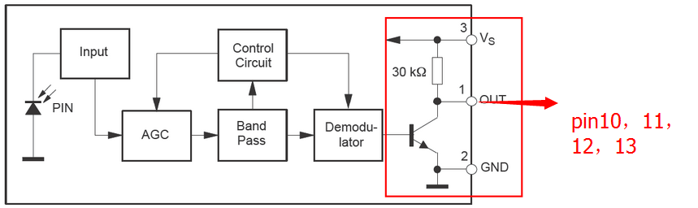

Design principal: when item go through the tunnel it will block the IR light, the state of receiver will change and we can get the responding signal from microcontroller.

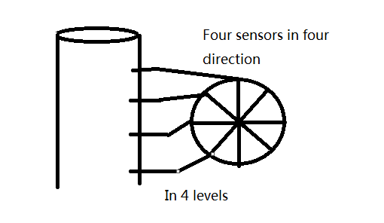

So, if sensor 1 or 2 or 3 or 4, any one of them detects the item the counter will get a trigger signal and then count one.

**Motor Selection**

After careful examination of the system’s static and dynamic characteristics it was determined that a motor with a minimum torque output of 20oz.-in. would be sufficient. Given that the there is considerable torque loss in the shaft of any given motor (~10%) and the need to both observe and control the speed of the motor it was determined that the 131:1 gear motor offered by Pololu was a desirable material solution for the motoring needs of the system. This motor offers 250 in-oz. of torque at 80 rpm, giving a safety factor of 12.5 and an encoder resolution of 64 counts per revolution, creating enough sample for an adequate velocity measurement.



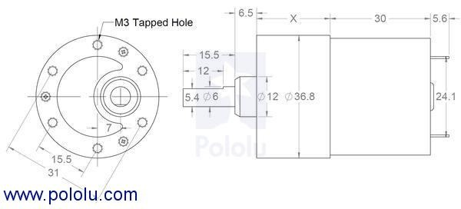

**Motor Drive**

To control the torque of the motor, a specific motor driving circuit is necessary. The figure below depicts the schematic for the motor driver circuit. The designed circuit is a N-MOS H-bridge which will allow the motor to be driven in both directions if necessary. Current to the motor can be applied by toggling the microcontroller pins connected to the four respective MOSFETs. Furthermore, a pulse width modulated signal can change the amount of power sourced to the motor which will change its respective torque. The circuit also contains protection diodes that will prevent the MOSFETs from receiving back current produced by the motor when the transistors are abruptly switched to stop the current. Using this circuit in conjunction with the control system detailed in a separate section will allow for precise control.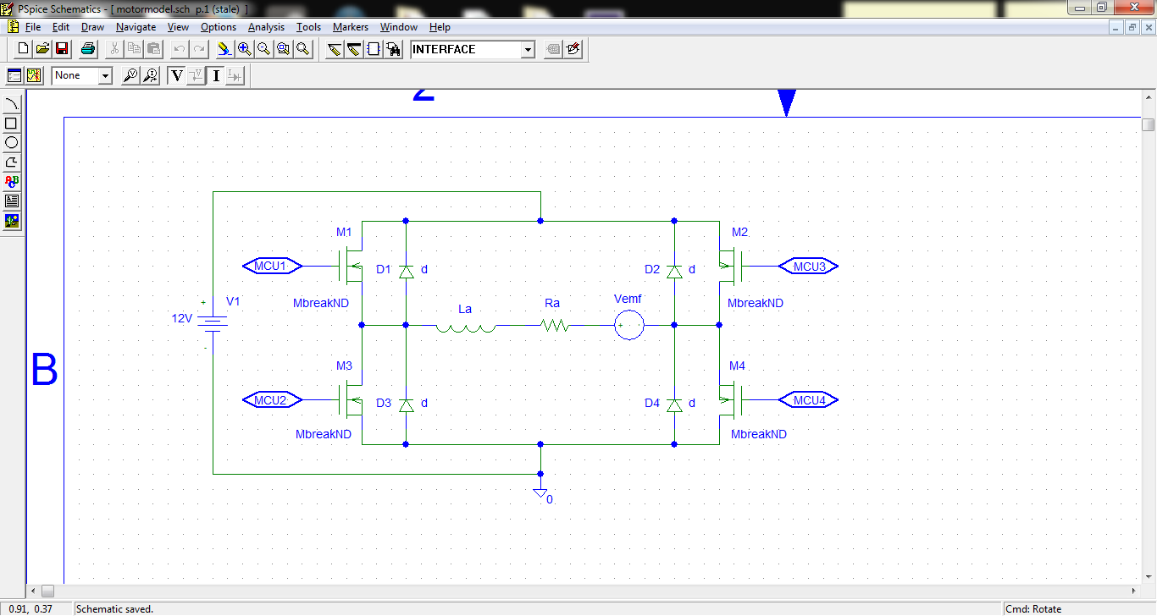l of the system.

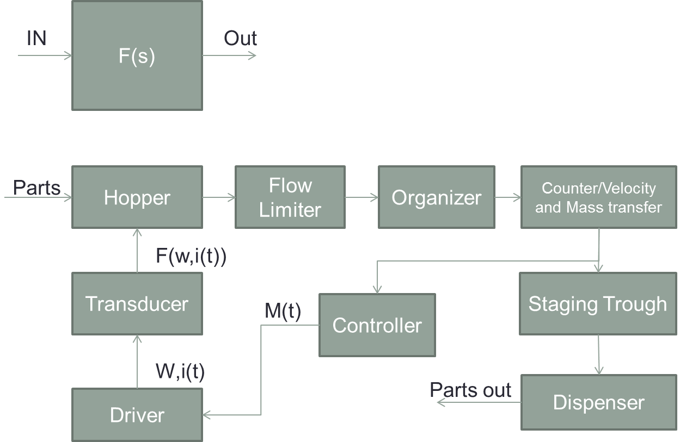

**Functional Block Diagram**

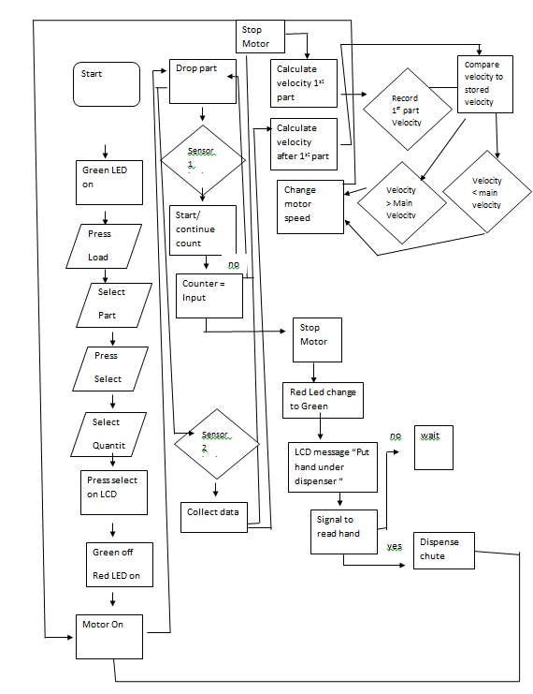

**Program Flow Chart**

**Expected Specifications and Features**

**Motor Specifications:**

## Dimensions

|  |  |
| --- | --- |
| **Size:** | 37D x 69L mm |
| **Weight:** | 8.1 oz |
| **Shaft diameter:** | 6 mm |

## General specifications

|  |  |
| --- | --- |
| **Gear ratio:** | 131:1 |
| **Free-run speed @ 6V:** | 40 rpm[1](http://www.pololu.com/product/1447/specs#note1) |
| **Free-run current @ 6V:** | 250 mA[1](http://www.pololu.com/product/1447/specs#note1) |
| **Stall current @ 6V:** | 2500 mA[1](http://www.pololu.com/product/1447/specs#note1) |
| **Stall torque @ 6V:** | 125 oz·in[1](http://www.pololu.com/product/1447/specs#note1) |
| **Free-run speed @ 12V:** | 80 rpm |
| **Free-run current @ 12V:** | 300 mA |
| **Stall current @ 12V:** | 5000 mA |
| **Stall torque @ 12V:** | 250 oz·in |
| **Lead length:** | 11 in |

## Notes:

1

This motor will run at 6 V but is intended for operation at 12 V.

**IR Sensor Specifications:**

**IR led : IR333-A**

Features

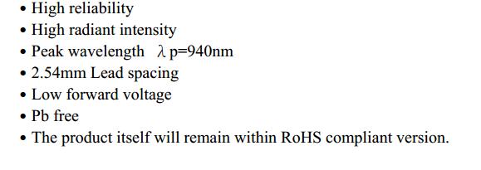

**IR receiver:** **TSOP34338**

Features:

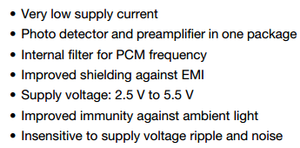

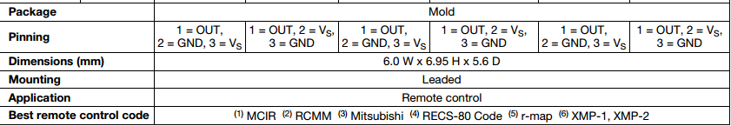

**Microcontroller Specifications**\*

|  |  |
| --- | --- |
| **PRODUCT INFORMATION** | |
| SKU | 194746 |
| Mfr Part# | 194159 |
| UPC | 618996977871 |
| **BOARDS/PROJECTS** | |
| Board Type | Arduino Mega2560 |
| Components | Mainboards |
| **MAINBOARDS** | |
| Board Color | Blue |
| Processor | ATmega2560 Microcontroller |
| Clock Rate | 16MHz |
| Operating Voltage | 5V |
| Input Voltage | 7V - 12V |
| Input Voltage (Limits) | 6V - 20V |
| Digital I/O Pins | 54 (of which 15 provide PWM output) |
| Analog Input Pins | 16 Pins |
| DC Current per I/O Pin | 40mA |
| DC Current for 3.3V Pin | 50mA |
| Flash Memory | 256KB |
| SDRAM | 8KB |
| EEPROM | 4KB |
| **WHAT IS IN THE BOX** | |
| What's in the Box | Arduino Mega 2560 |

*Specifications gleaned from http://www.microcenter.com/product/431995/Arduino_Mega_2560

**Design Considerations**

**Mechanical Design Considerations**

In order to come up with our design extensive research was done to see how parts are moved, counted, stored, contained and controlled in real world settings. After exploring some examples we started to consider our own design additions to make or add to designs that would in theory mimic the results of massive modern parts counting machines. We took away key pieces that each machine seemed to achieve to make it successful.

In order to choose a design, a chart was created for each feature that would have to take place in the machine. The events were ordered to follow the path of a single small part through each step in the machine’s processes. Where each step would need to physically be controlled and have the capability for an electrical system to view and provide feedback to the machines main electrical controls.

In order to hold the parts the machine needed a larger bin or space that could feed parts to the rest of the machine. The model of the bowl design in the case feeder could hold large amounts of small parts and would be providing continuous feeding to the machine. Other hopper designs where considered however, it was deemed not necessary due to the expected part volume being too small to add another major part storage device.

The machine has to be able to physically move the small parts from the hopper to the rest of the machine, and it must do so efficiently and orderly. In order to move the parts, many examples that were observed used vibration methods, conveyor belts, rail systems and good old gravity. It was decided for this machine to attempt to use a gravity feed method that performed by agitating the parts into one orientation in its bowl. It then allowed only one part per slot, acquired each part one by one and separated them from the main parts population in an orientation that could be used for counting.

From the systems major flow of parts the amount of parts exiting the upstream portion of the machine was limiting the flow by means of spaces and gaps that would allow parts of one orientation to move through without falling back into the main population at the bottom of the bowl. These limitations allowed for a single oriented and controlled line of parts to be fed to the rest of the machine. For this project the machine will use multiple disks to limit the size of fastener allowed in a slot. Each disk is made with only one fastener in mind and takes into account thicknesses, length and width. In order to change fasteners the operator will stop the machine, empty the remaining content, take off one plate and reinstall a new plate dedicated to the new part being put into the machine.

Once oriented and position to a single feed made slower accurate counting easier. It has been noted that some machines can count multiple small parts moving out to the machine at once, however the accuracy of the count and the speed of the machine have been deemed a risk to our application. It is recognized that this machine has been made to feed slowly to ensure accuracy and control of both the parts and the count. It is decided to use multiple sensors so that we can read multiple counts and compare counts to determine the correct count in the machine. We are confident in our counting abilities that we will collect the screw in one presentation bin.

The last method that each machine provided was to deliver the parts to their final holding area or destination. The project destination is a waiting hand; however the maximum number of parts to be presented is limited. Due to this we developed the idea based off of a soap dispenser, soda fountain, and ice water dispenser from a refrigerator, where the user puts a cup or a hand under the count holder and pushes a bumper that will allow for the parts to be dispensed vertically. We have put this bin on a rail system in combination with the slide. This allows the slide to be supported by the bin. Between the bin and the slide we will install two tension springs that will be about 58mm at rest and be able to stretch 128mm without yielding. The spring constant will be tested and set such that the springs will reposition the slide when the operator lets off but not be so high that the operator strains to release the parts.

In order to contain the machine and support components we thought of building a cage where the machine components would be inside. Cage would act as a frame and would be built out of columns and beams to provide support to the components within the machine. It was noted that a machine in the senior design room was using a support system mainly out of 8020 beams and connectors that could be ordered in smaller sizes and be tailored to fit this machine. These pieces will hold up the case feeder bowl, the dispensing bin, the funnel and the electronic interface at the front of the machine. The frame will be fitted Plexiglas to allow for observation but with a protective barrier between users a machine. It also serves to prevent foreign material from entering the machine. The frame supports the main assembly above the surface of the table and allows for a 160mm gap for the operator to put his/her hand into interacting with the presentation bin and slider.

In order to move parts in the machine we use disks that are attached to a slow moving servo motor in order to mix the parts and feed them to the funnel for counting. The geometry of each plate is such that only one part can fit into a slot on the plate. The rest will be dropped back down to the rest of the population. One disk will be made for each part. By using similar key features, we will be able to change the disks quickly to allow different parts to be held, oriented, and moved by the disk. It has been noted that one fastener has a pointed tip which could cause damage to the machine. In order to prevent this we will put a tapper into the edge in order to catch the fastener and not allow for wear in the machine. We plan to use ABS for both the bowl and the disks so that the friction constant between the two remains low.

The funnel in the design allows us to attach sensors for parts coming through the machine to count. It also orients the parts as they are falling into the presentation bin. By using 2 counters we can confirm the count and of each part and stop the motor at the correct count.

**Electrical and Controls Design Considerations**

Some of the key electrical design considerations include:

* Power Supply
* Motor selection and control
* Sensor selection and design requirements
* Microcontroller selection

**Power Supply:**

The power supply necessary for this design is one that can provide a 12V and 5V bus from a standard 110VAC single-phase line. The power supply would employ the use of an isolation transformer and a full-wave bridge rectifier. Each rectifying diode in the bridge rectifier shall have a peak inverse voltage (PIV) capacity of 30 V. At the output of the rectifier would be a 100uF electrolytic capacitor as is standard in power supply design to smooth out the ripples left in the rectification process. Then the smoothed power signal would be passed through two voltage regulators in parallel, a 12V and a 5V voltage regulator. After the voltage regulators would await another set of 100uF electrolytic capacitors to provide further noise immunity for the control and motor circuits.

**Motor Selection and Control:**

After careful examination of the system’s static and dynamic characteristics it was determined that a motor with a minimum torque output of 20oz.-in. would be sufficient. Given that the there is considerable torque loss in the shaft of any given motor (~10%) and the need to both observe and control the speed of the motor it was determined that the 131:1 gear motor offered by Pololu was a desirable material solution for the motoring needs of the system. This motor offers 250 in-oz. of torque at 80 rpm, giving a safety factor of 12.5 and an encoder resolution of 64 counts per revolution, creating enough sample for an adequate velocity measurement. Control can be performed by implementing a PID controller in software on the microcontroller to control velocity output for desired velocity state or an integrated motor controller can be purchased that controls the motor with only a simple command from the microcontroller controlling the rest of the system. Given allocated memory and system response time it might be desired to control the motor using a motor controller.

**Sensor selection and design requirements:**

It was decided to use theusing IR led to make IR emit and receive system.The Components: A 5mm IR led, IR receiver: TSOP34338, Arduino 2560 R3, Cylinder crust, resister and wires It is not necessary to add a lens in emit system, because IR led has already had similar structure. The IR-333A LED offers high-reliability and low forward voltage. The TSOP34338 IR receiver offers a detector and preamplifier in one convenient package, while also being immune to ambient light. In order to detect item accurately, we have to consider using which way to send and to receive signal. The light from IR cannot gather into one point in our system. So, we need to consider the reflection of IR light and disturbing between each IR sensors. Therefore, taking example by IR remoter, we may choose to use IRRemote function library to add compiling signal on carrier wave if the result is unsatisfactory when use receiver to detect IR pulse signal.

**Microcontroller Selection:**

The microcontroller selected, the Arduino Mega 2560 R3, was selected due to its intuitive and easy to program interface and native language; Wirish. Also, this particular board offers the right combination of needed PWM and UART ports to support the operation of the sensors, LCD HMI, and motor control. The board offers 15 PWM ports and 3 UART serial communication lines. The board also is clocked at 16MHz which allows the generation of the 26us pulse needed to achieve the 38kHz carrier signal for the IR sensors and also allows a single instruction to be executed in 62.5 ns. Furthermore, the RISC architecture that is inherent in the Atmel core design allows the micro to execute instructions more efficiently, optimizing computation throughput for a given clock frequency.

**Feasibility Analysis**

**Physical Feasibility**

To control the angular speed of the plate in the bowl, the physics of the system can be modeled and a control system can be implemented. Analyzing the rotation of the plate about the axis of the rotor of the DC servo motor, the equation of motion can be actualized as the sum of torques written as follows:

where is the moment of inertia of the plate and parts system and is the angular acceleration. Recognizing that the torques acting on the plate consist of the input torque, , from the electric motor and the viscous friction between the plate and the bowl, , the equation of motion can be rewritten to contain these terms. The equation of motion now reflects the following expression:

The viscous friction term can be expressed as:

where b is the viscous friction coefficient and is the angular velocity. Substituting the expression for viscous friction, the equation of motion can be rewritten again as followed:

To prepare the equation of motion for modeling in MATLAB, the equation can be rearranged to solve for the angular velocity. Rearranging yields the expression:

With the equation of motion in the form necessary for state space representation, the state space variables can be declared as follows:

Using these state space variables, the state space representation can be determined. The state space matrices can be written accordingly:

As can be noticed from these expressions, the input will be the torque from the motor and the output will be the angular velocity of the plate. The torque from the motor can be adjusted using pulse width modulation and the motor driver circuit described in detail in a separate section. The angular velocity of the plate will be monitoring using a rotary encoder and will provide effective feedback to the system.

In addition to modeling the physics of the system, an appropriate control system can be developed to control the DC servo motor. Below, the independent DC servo motor controller will be implemented to ensure the motor will produce the desired torque in order to maintain the optimal angular velocity for the plate.

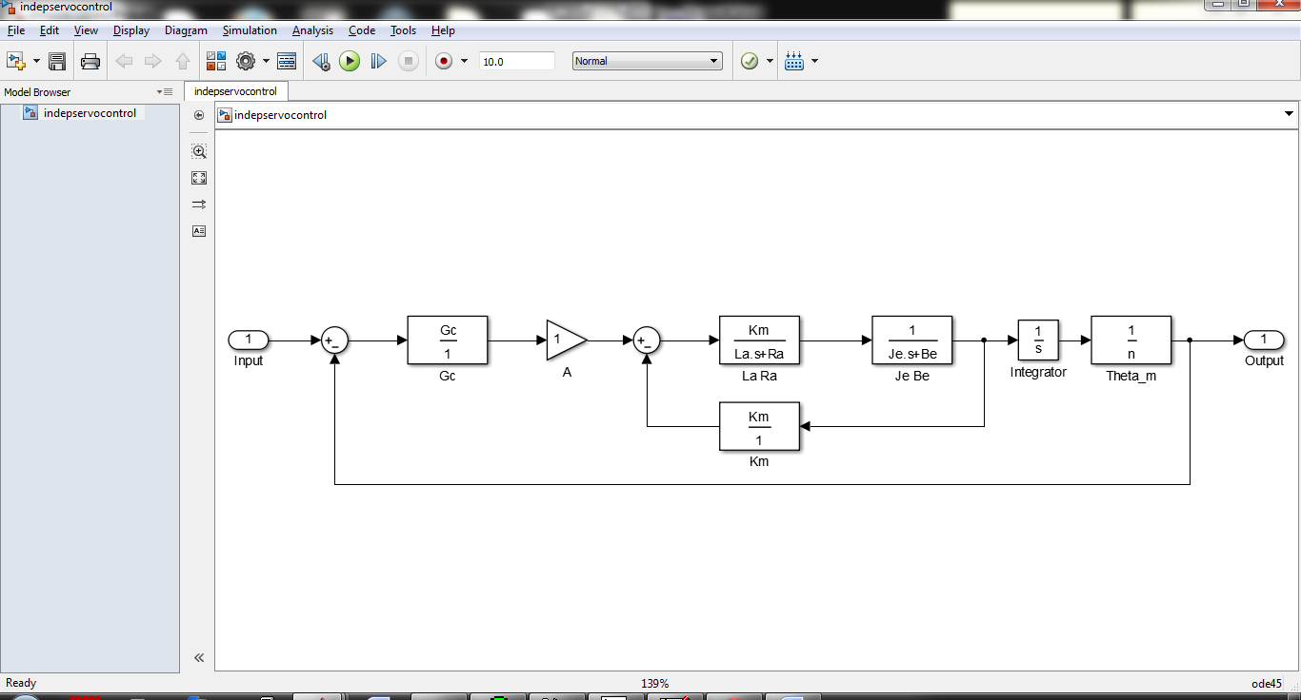

The control system will need the appropriate constants for the motor. In particular the armature resistance, , and armature inductance, , and motor constants, and will be measured or obtained from the selected motor’s data sheet. As a result, fine-tuned control of the motor and rotating plate will be achieved for precise delivery of the desired quantity of parts in the appropriate time window.

**Financial Feasibility**

The overall cost of the system will be determined by the building materials, microcontroller, and the electromagnets to power the system. For building materials, the bowl is planned to be 3D printed from ABS plastic. A 1kg reel of ABS plastic can be purchased at Microcenter for $15.99. Additionally, the frame will need to be built out of aluminum angle pieces. These pieces can be purchased in lengths of 96 inches for $18.54. We anticipate the need for 13 feet of aluminum angle for the frame and mounting pieces. The microcontroller we will be using retails for $19.99. Lastly, sufficient electromagnets such as a 50kg holding force magnet cost $19.29. The sum of these materials for the build adds to $111.64. An additional $50 should be allotted for other expenditures for prototyping and other small components. Even with this extra allowance for additional parts, the system falls well within reasonable financial limits.

**Potential Markets and Applications**

The system could efficiently and accurately count parts needed by an assembly worker and dispenses those parts into a worker’s awaiting hand. This kind of function can be applied in many related fields and across several industries. One such field that would greatly benefit from this type of device is manufacturing. As manufacturing facilities become more advanced the need to save on time in the form of throughput and money in the form of fastener and raw build material will become more important. A similar device as this one, if properly deployed, could save a firm both in terms of time and money. Another area that could benefit from this design would be hardware distributors. Hardware typically comes in a bag of anywhere from 2 to 20 parts, various kinds of fasteners.

Before packaging, catching the exactly number of parts to be packaged is important. Instead counting the parts by human being, which is grossly prone to error, a machine could proper do the work effectively and accurately. Additionally, the machine can count different types and different numbers of small parts by easily changing or adjusting the components.

Although the system is now just suitable for no more than 50 parts, it can be developed to fit more parts to work better in the real industry. Further, this vibration system also can not only used to count one kind of parts, after some changes, it also can be used to classify different kind of parts, which will be very useful in cross industry applications.

Another market that could find benefit from such a device is the pharmaceutical market. From pill factories to the local pharmacy, accurate counting of one’s medicine has always been a critical task. When left in the hands of this machine that task is made more certain to be done right every time.

**Project Timeline**

